Chapter 9, Problem 48.

Given that v_{s}(t) = 20 sin(100t - 40°) in Fig. 9.55, determine i_{x}(t).

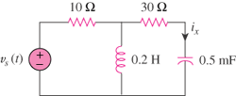

Figure 9.55
For Prob. 9.48.

